KickStarter Analysis

Data Analytics Boot Camp – TTh Class

Dale Ohmart, Nov 11, 2018

Quick Conclusions from Assigned Graphs

The view based on top-level category makes is very quickly apparent that KickStarter is primarily used as a tool for funding artistic endeavors. Theater, music, film & video are three of the top four categories, and photography and publishing are also significant. Theater projects dominate, greater than two times the next category, music.

It further appears that the artistic projects have a higher likelihood of achieving their KickStarter financial objectives. However, that data may be somewhat skewed, as I observed that many KickStarter objectives are ridiculously small, as little as $1. This deserves a bit more analysis, before making any conclusions about success ratio. It does make me wonder how KickStarter works. What happens if the financial objective is not met? All funds are returned to “investors?” On the other hand, if the financial objective is met, then the project receives the funding? I also observed that KickStarter allows “overfunding” (funds in excess of the goal). If this is the rule set, then there would be a strong incentive for a project developer to set very low goals, thus walking away with whatever level of funding is pledged.

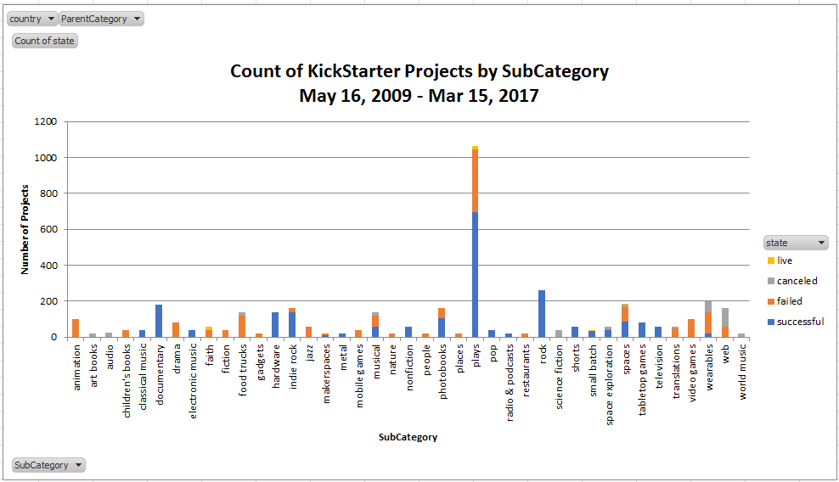

The subcategory view makes a few conclusions abundantly clear. In eight, there has not been a successful food truck, video game, or mobile game. The highest levels of success are, again, artistic in nature.

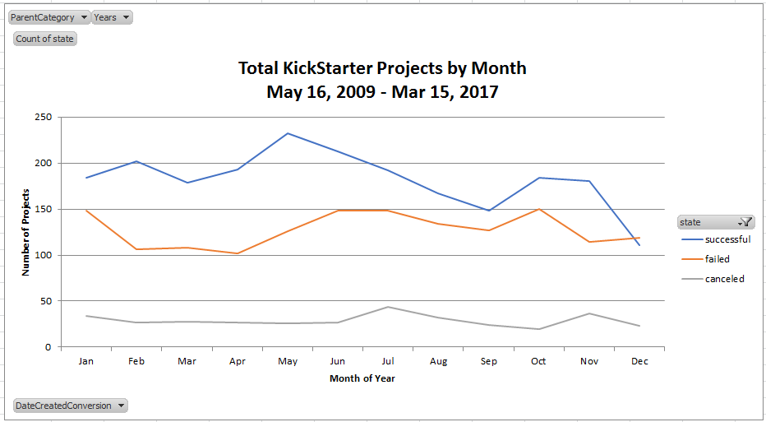

Finally, the monthly trend chart seems to indicate that very few projects are started in December. That seems logical. It also shows that the number of cancelled projects is fairly steady throughout the year, but the number of successful projects seems to come from those started in the first half of the year.

There is a lot more information embedded in this dataset. Switching to a slightly more powerful visualization tool allows some quick looks.

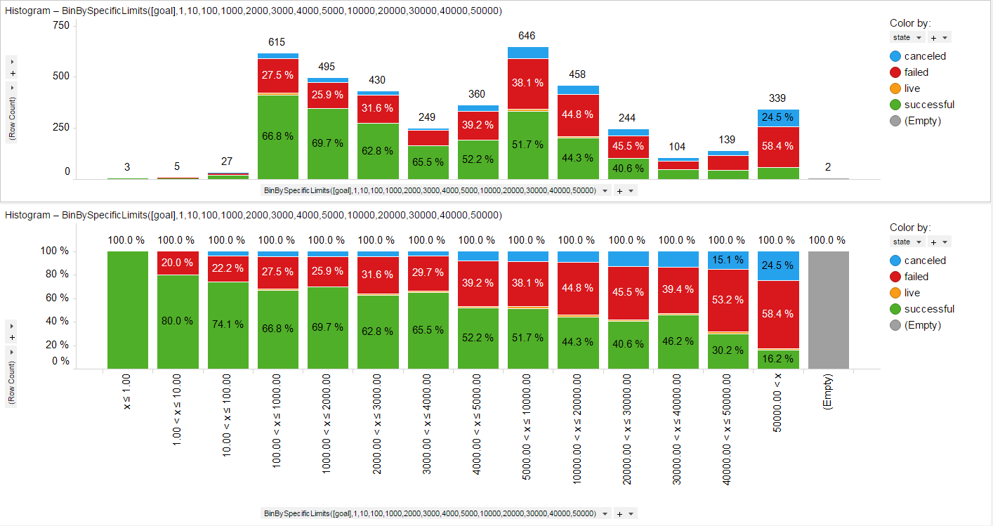

This histogram of goals (on X-Axis, notice that the increments are not smooth, first few are logarithmic jumps, then they go to linear by $1,000, then jump to linear by $10,000). Top graph is standard histogram, bottom is normalized to 100% of number of projects in each financial goal group. It is clear that as the goal goes up, success rate falls.

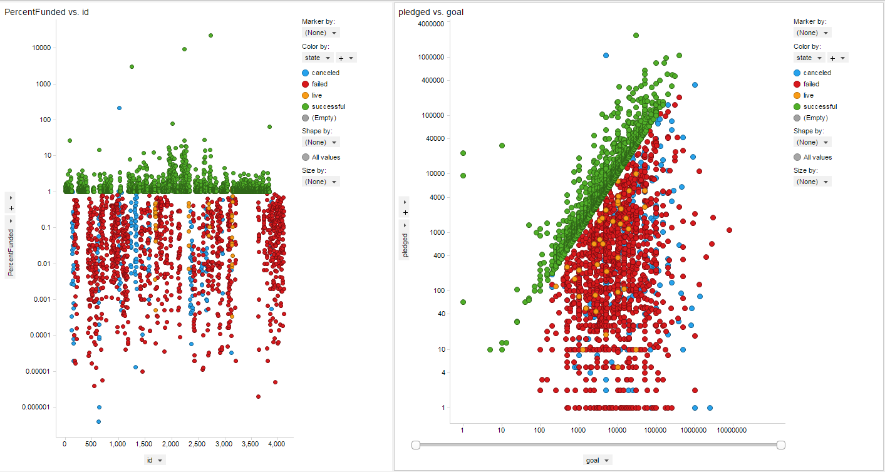

However, this view shows that KickStarter must have some scheme in place to prevent abuse. The vast majority of successful projects are funded somewhere between 1 and 10 times the goal (left graph – shows % Fundec vs Project ID number on the X-Axis).

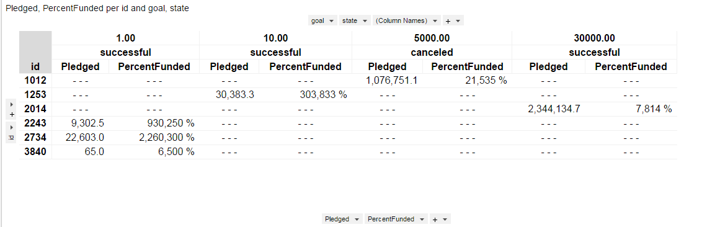

The small number of highly overfunded projects are mostly at very low goals. Though two of the projects, interestingly, are funded at >$1M. One of these two was cancelled.



KickStarter may be a fad. Or it’s use may have peaked, in any case.

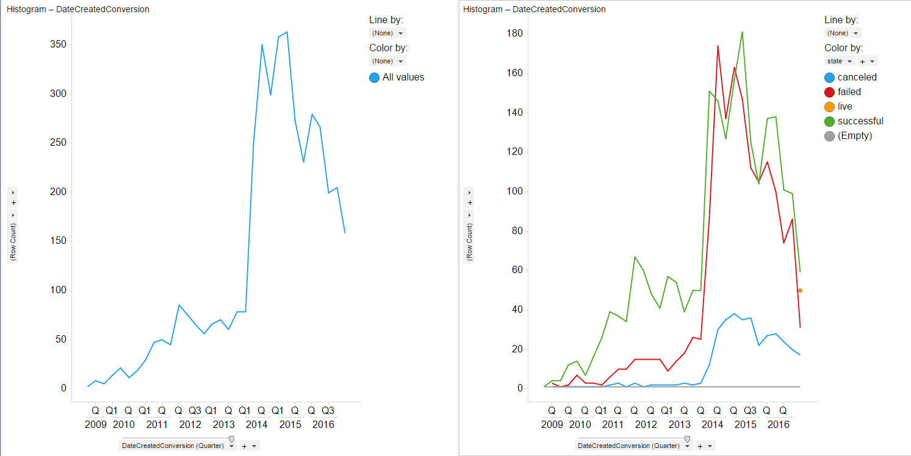

On the other hand, the pledge stream that KickStarter is pulling in continues to increase. Dropping the incomplete 2017 data, looking at annual pledge totals:

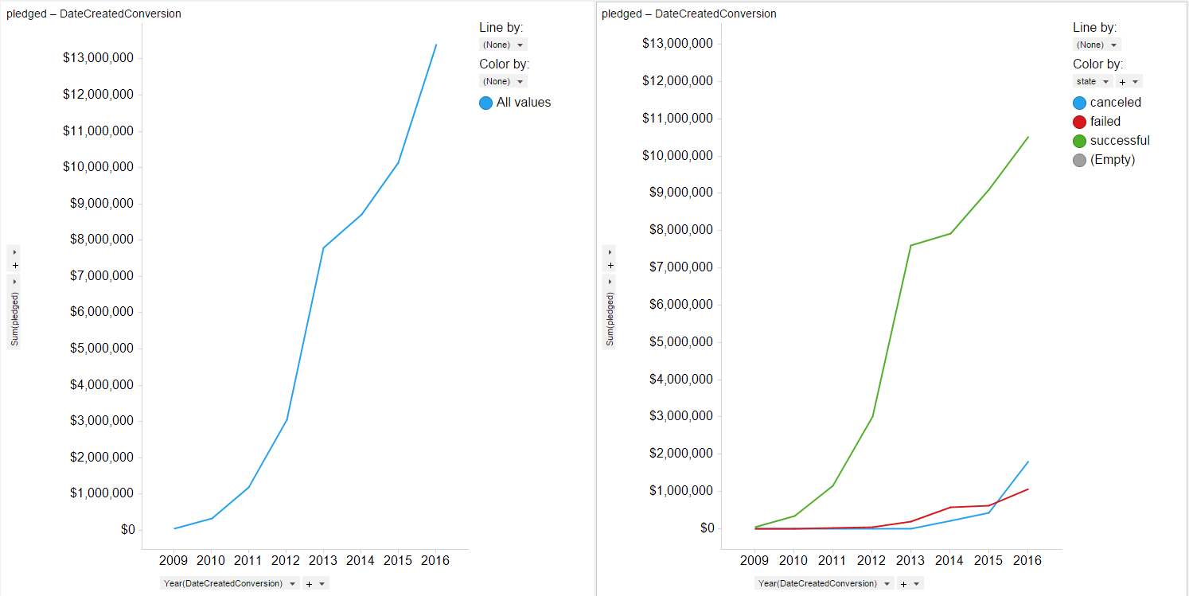

So perhaps what is happening is that users are getting better at knowing what KickStarter is good for, and what it is not good for.

A Few Things We Cannot Learn

There are a few things we can’t really learn from this dataset. For instance, we have the total contributions, but no other data on contributions. So it is not possible to tell is donations are highly concentrated or widely distributed. This is important, as the idea of KickStarter was to give users access to a widely distributed funding network. And to provide “retail investors” with the ability to invest in projects interesting to them. If instead, contributions are highly concentrated, then KickStarter is not completely successful in meeting the original intent.

Second, from the dataset (see pledged vs goal graph above), it is clear that the definition of “success” is that the goal contribution is achieved through pledges. This tells nothing about the ultimate success of the project being funded. Was the play actually staged? The movie made? The record cut? There is no way to tell. And again, the idea behind KickStarter was to fund interesting projects, most of which it was hoped would be successful.

The data is not complete for 2009 or 2017, so annualized views are really only good for 7 years, 2011 – 2016.

Bonus Exercise

Just for fun….because actually, this is kind of what I did in Spotfire when I was digging into what could and could not be learned. It was a heck of a lot easier in Spotfire. Oh, well!

It took over an hour to get the formulae correct in this one! Granted I have objections to putting pass/fail criteria directly in the formulae, so I put them in hidden columns and rows, so the base formula was more complicated. But the bigger issue was jumping back and forth between sheets to try to get the right column. Took a while to figure that out.

